**VIRTUAL PET ANGGORA**

1. **Deskripsi Virtual Pet**

Anggora adalah kucing dengan ciri khas berbulu panjang yang indah. Anggora memiliki tubuh yang sedang dengan badan berotot yang panjang, ramping, langsing dan elegan. Anggora memiliki hidung yang panjang, kepala yang berbentuk segitiga, serta telinga yang panjang, lebar, dan berbentuk segitiga.Kucing ini sangatlah lucu , aktif,dan manja terhadap majikannya akan tetapi mereka bisa marah jika dihiraukan.Anggora perilakunya seperti kucing pada umumnya misalnya makan,bermain,tidur,merasa bosan,senang,kenyang,marah ,dan juga bisa kabur dari rumah.

1. **Daftar Aksi**

|  |  |  |  |  |  |
| --- | --- | --- | --- | --- | --- |
| Transisi | Makan | Bermain | Tidur | Cari | Diamkan |
| Bosan | Kenyang | Senang | Lapar | Bosan | Marah |
| lapar | Kenyang | lapar | lapar | lapar | Marah |
| kenyang | Kenyang | Lelah | Senang | Kenyang | Bosan |
| lelah | Kenyang | Marah | Senang | Lelah | Marah |
| Senang | Kenyang | Lapar | Senang | Bosan | Bosan |
| Marah | Senang | Marah | Senang | Marah | Hilang |
| Hilang | Hilang | Hilang | Hilang | Lelah | Hilang |

**Deskripsi Aksi dan State**

Aksi-aksi yang dapat diinputkan oleh user yaitu :

1. Beri Makan
2. Ajak Main
3. Suruh Tidur
4. Cari
5. Diamkan

Setelah mendapatkan input dari user,Kucing Anggora akan memberikan reaksinya,antara lain :

1. Bosan
2. Lapar
3. Kenyang
4. Lelah
5. Marah
6. Hilang
7. Senang
8. **Definisi Formal**

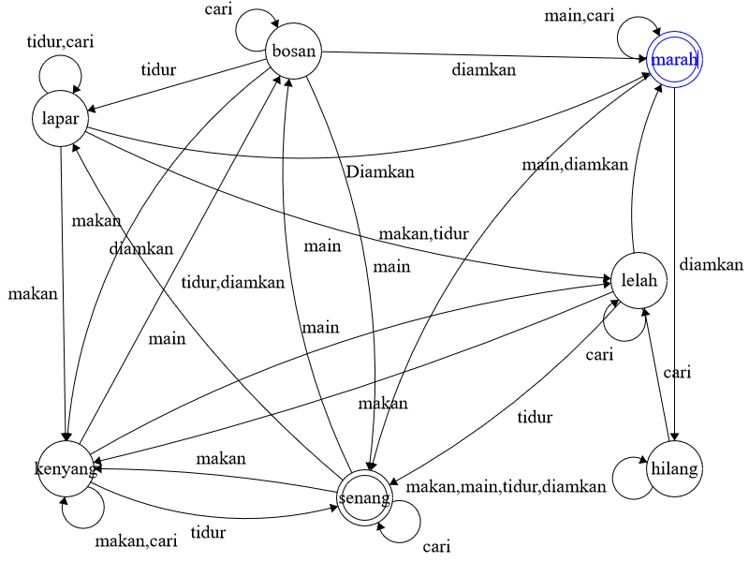

1. **Definisi Formal**

Q = {Bosan,Lapar,Kenyang,Lelah,Marah,Hilang,Senang}

Σ = {Beri Makan,Ajak Main,Suruh Tidur,Cari,Diamkan }

S = {Bosan}

F = {Senang, Marah}

1. **Source Code**

**package ProjectVirtual;**

**import java.util.Scanner;**

**/\*\***

**\***

**\* @MuhammadHananAbabil**

**\*/**

**public class VirtualPet {**

**public static String nama, aksi;**

**public static int state;**

**static Scanner input = new Scanner(System.in);**

**static final int bosan = 1;**

**static final int lapar = 2;**

**static final int kenyang = 3;**

**static final int lelah = 4;**

**static final int senang = 5;**

**static final int hilang = 6;**

**static final int marah = 7;**

**static final int quit = 9;**

**public static void main(String[] args) throws InterruptedException {**

**VirtualPet run = new VirtualPet();**

**run.main();**

**}**

**public void main() throws InterruptedException {**

**kucing();**

**intro();**

**while (state != quit) {**

**switch (state) {**

**case bosan:**

**Bosan();**

**break;**

**case lapar:**

**Lapar();**

**break;**

**case kenyang:**

**Kenyang();**

**break;**

**case lelah:**

**Lelah();**

**break;**

**case senang:**

**Senang();**

**break;**

**case hilang:**

**Hilang();**

**break;**

**case marah:**

**Marah();**

**}**

**}**

**}**

**public void Menu() {**

**System.out.println("Lakukan Sesuatu : ");**

**System.out.println("1. Beri Makan");**

**System.out.println("2. Ajak Main");**

**System.out.println("3. Suruh Tidur");**

**System.out.println("4. Cari");**

**System.out.println("5. Diamkan");**

**System.out.println("6. Keluar Program");**

**System.out.print("Masukan Pilihan Anda : ");**

**}**

**public void garis() {**

**System.out.println("==========================================");**

**}**

**public void Bosan() throws InterruptedException {**

**int action;**

**do {**

**garis();**

**System.out.println(nama + ", Terlihat Bosan..");**

**System.out.println(nama + ", Sedang Duduk termenung tanpa melakukan Apa-Apa....");**

**Menu();**

**action = input.nextInt();**

**garis();**

**if (action == 1) {**

**aksi = "makan";**

**state = kenyang;**

**} else if (action == 2) {**

**aksi = "main";**

**state = senang;**

**} else if (action == 3) {//tidur**

**state = lapar;**

**aksi = "tidur";**

**} else if (action == 4) {//cari**

**aksi = "dicari";**

**state = bosan;**

**} else if (action == 5) {//diamkan**

**state = marah;**

**aksi = "didiamkan";**

**} else if (action == 6) {//keluar**

**System.err.println("Keluar Game");**

**System.out.println("Terima Kasih Anda Telah Bermain");**

**state = quit;**

**} else {**

**System.out.println("Input anda Salah");**

**garis();**

**}**

**if (action >= 1 && action <= 5) {**

**System.out.println(nama + " Sedang " + aksi);**

**}**

**for (int i = 0; i <= 30; i++) {**

**System.out.print('\u1219');**

**Thread.sleep(120);**

**}**

**System.out.println();**

**} while (action < 1 || action > 6);**

**}**

**public void Lapar() throws InterruptedException {**

**int action;**

**do {**

**garis();**

**System.out.println("Perut " + nama + " Mengeluarkan bunyi yang aneh!!");**

**System.out.println(nama + " Sesekali Melirik Kearah Makanan ");**

**Menu();**

**action = input.nextInt();**

**garis();**

**if (action == 1) {//Makan**

**state = kenyang;**

**aksi = "makan";**

**} else if (action == 2) {//Main**

**state = lelah;**

**aksi = "main";**

**} else if (action == 3) {//tidur**

**state = lapar;**

**aksi = "tidur";**

**} else if (action == 4) {//cari**

**state = lapar;**

**aksi = "dicari";**

**} else if (action == 5) {//diamkan**

**state = marah;**

**aksi = "Didiamkan";**

**} else if (action == 6) {//keluar**

**System.err.println("Keluar Game");**

**System.out.println("Terima Kasih Anda Telah Bermain");**

**state = quit;**

**} else {**

**System.out.println("Input anda Salah");**

**}**

**if (action >= 1 && action <= 5) {**

**System.out.println(nama + " Sedang " + aksi);**

**}**

**for (int i = 0; i <= 30; i++) {**

**System.out.print('\u1219');**

**Thread.sleep(120);**

**}**

**System.out.println();**

**} while (action < 1 || action > 6);**

**}**

**public void Kenyang() throws InterruptedException {**

**int action;**

**do {**

**garis();**

**System.out.println(nama + ", Kekenyangan");**

**System.out.println(nama + ", Duduk dan sekekali menguap...");**

**Menu();**

**action = input.nextInt();**

**garis();**

**if (action == 1) {//makan**

**state = kenyang;**

**aksi = "makan";**

**} else if (action == 2) {//Main**

**state = lelah;**

**aksi = "main";**

**} else if (action == 3) {//tidur**

**state = senang;**

**aksi = "tidur";**

**} else if (action == 4) {//cari**

**state = kenyang;**

**aksi = "Dicari";**

**} else if (action == 5) {//diamkan**

**state = bosan;**

**aksi = "Didiamkan";**

**} else if (action == 6) {//keluar**

**System.err.println("Keluar Game");**

**System.out.println("Terima Kasih Anda Telah Bermain");**

**state = quit;**

**} else {**

**System.out.println("Input anda Salah");**

**garis();**

**}**

**if (action >= 1 && action <= 5) {**

**System.out.println(nama + " Sedang " + aksi);**

**}**

**for (int i = 0; i <= 30; i++) {**

**System.out.print('\u1219');**

**Thread.sleep(120);**

**}**

**System.out.println();**

**} while (action < 1 || action > 6);**

**}**

**public void Lelah() throws InterruptedException {**

**int action;**

**do {**

**garis();**

**System.out.println(nama + ", Kelelahan..");**

**System.out.println(nama + ", Terlihat ngosngosan dan menjulurkan lidahnya");**

**Menu();**

**action = input.nextInt();**

**garis();**

**if (action == 1) {//makan**

**state = kenyang;**

**aksi = "makan";**

**} else if (action == 2) {//Main**

**state = marah;**

**aksi = "main";**

**} else if (action == 3) {//tidur**

**state = senang;**

**aksi = "tidur";**

**} else if (action == 4) {//cari**

**state = lelah;**

**aksi = "Dicari";**

**} else if (action == 5) {//diamkan**

**state = marah;**

**aksi = "didiamkan";**

**} else if (action == 6) {//keluar**

**System.err.println("Keluar Game");**

**System.out.println("Terima Kasih Anda Telah Bermain");**

**state = quit;**

**} else {**

**System.out.println("Input anda Salah");**

**garis();**

**}**

**if (action >= 1 && action <= 5) {**

**System.out.println(nama + " Sedang " + aksi);**

**}**

**for (int i = 0; i <= 30; i++) {**

**System.out.print('\u1219');**

**Thread.sleep(120);;**

**}**

**System.out.println();**

**} while (action < 1 || action > 6);**

**}**

**public void Senang() throws InterruptedException {**

**int action;**

**do {**

**garis();**

**System.out.println(nama + ", Terlihat sangat senang");**

**Menu();**

**action = input.nextInt();**

**garis();**

**if (action == 1) {//makan**

**state = kenyang;**

**aksi = "makan";**

**} else if (action == 2) {//Main**

**state = lapar;**

**aksi = "main";**

**} else if (action == 3) {//tidur**

**state = bosan;**

**aksi = "tidur";**

**} else if (action == 4) {//cari**

**state = senang;**

**aksi = "Dicari";**

**} else if (action == 5) {//diamkan**

**state = bosan;**

**aksi = "Didiamkan";**

**} else if (action == 6) {//keluar**

**System.err.println("Keluar Game");**

**System.out.println("Terima Kasih Anda Telah Bermain");**

**state = quit;**

**} else {**

**System.out.println("Input anda Salah");**

**garis();**

**}**

**if (action >= 1 && action <= 5) {**

**System.out.println(nama + " Sedang " + aksi);**

**}**

**for (int i = 0; i <= 30; i++) {**

**System.out.print('\u1219');**

**Thread.sleep(120);**

**}**

**System.out.println();**

**} while (action < 1 || action > 6);**

**}**

**public void Hilang() throws InterruptedException {**

**int action;**

**do {**

**garis();**

**System.out.println("Tidakkkk.... " + nama + " tidak ada dirumah..");**

**System.out.println(nama + " Telah Hilang!!!!");**

**Menu();**

**action = input.nextInt();**

**garis();**

**if (action == 1) {//makan**

**state = hilang;**

**aksi = "makan";**

**} else if (action == 2) {//Main**

**state = hilang;**

**aksi = "main";**

**} else if (action == 3) {//tidur**

**state = hilang;**

**aksi = "tidur";**

**} else if (action == 4) {//cari**

**state = lelah;**

**aksi = "Dicari";**

**} else if (action == 5) {//diamkan**

**state = hilang;**

**aksi = "Didiamkan";**

**} else if (action == 6) {//keluar**

**System.err.println("Keluar Game");**

**System.out.println("Terima Kasih Anda Telah Bermain");**

**state = quit;**

**} else {**

**System.out.println("Input anda Salah");**

**garis();**

**}**

**if (action >= 1 && action <= 5) {**

**System.out.println(nama + " Sedang " + aksi);**

**}**

**for (int i = 0; i <= 30; i++) {**

**System.out.print('\u1219');**

**Thread.sleep(120);**

**}**

**System.out.println();**

**} while (action < 1 || action > 6);**

**}**

**public void Marah() throws InterruptedException {**

**int action;**

**do {**

**garis();**

**System.out.println(nama + ", Marah kepada anda!!");**

**System.out.println(nama + ", Mengeluarkan taringnya!!!");**

**Menu();**

**action = input.nextInt();**

**garis();**

**if (action == 1) {//makan**

**state = senang;**

**} else if (action == 2) {//Main**

**state = marah;**

**} else if (action == 3) {//tidur**

**state = senang;**

**} else if (action == 4) {//cari**

**state = marah;**

**} else if (action == 5) {//diamkan**

**state = hilang;**

**} else if (action == 6) {//keluar**

**System.err.println("Keluar Game");**

**System.out.println("Terima Kasih Anda Telah Bermain");**

**state = quit;**

**} else {**

**System.out.println("Input anda Salah");**

**garis();**

**}**

**} while (action < 1 || action > 6);**

**}**

**public void kucing() {**

**System.out.println("____________________________________$$$$\n"**

**+ "__________________________________$$____$\n"**

**+ "_________________________________$_______$\n"**

**+ "___$$$$_________________________$_________$\n"**

**+ "__$____$$______________________$____$_____$\n"**

**+ "_$_______$$___________________$____$$$____$\n"**

**+ "_$_________$$_____$$$$_$$$___$____$$$$$___$\n"**

**+ "$____________$_$$$__$$$__$$_$____$$$$$$___$\n"**

**+ "$____$$_______$_$$__$$$__$$$____$$$$$$$___$\n"**

**+ "$___$$$$_______$$$$_$$$___$$_____$$$$$$___$\n"**

**+ "$___$$$$$$_____$$$$_$$$$__$$$______$$$$$__$\n"**

**+ "$___$$$$$$$____$$$$_$$$$__$$$________$$$__$\n"**

**+ "$___$$$$$______$$$$_$$$$__$$$$____________$\n"**

**+ "$___$$$$_______$$$$_$$$$__$$$$____________$\n"**

**+ "$___$$$________$$$$_$$$$__$$$$____________$\n"**

**+ "$___$$_________$$$$__$$$__$$$$____________$\n"**

**+ "$______________$$$___$$$___$$$____________$\n"**

**+ "$_______________$_____$_____$_____________$\n"**

**+ "_$_________________________________________$\n"**

**+ "$________________________________$$$$_______$\n"**

**+ "$_______________________________$__$$$______$\n"**

**+ "$__________$$$$________________$$__$$$$_____$\n"**

**+ "$_________$$$__$_______________$$$$$$$$_____$\n"**

**+ "$________$$$$__$_______________$$$$$$$$_____$\n"**

**+ "$________$$$$$$$$______________$$$$$$$$_____$\n"**

**+ "$________$$$$$$$$_______________$$$$$$______$\n"**

**+ "$________$$$$$$$$_______$___$____$$$$_______$\n"**

**+ "$_________$$$$$$_____$__$$_$________________$\n"**

**+ "$__________$$$$_______$$__$________________$\n"**

**+ "_$_____________________$__$_______________$\n"**

**+ "__$_____________________$$_______________$\n"**

**+ "___$______________________________$$$___$\n"**

**+ "____$$___________________________$___$_$\n"**

**+ "______$$$_______________________$_____$\n"**

**+ "_________$$$$_____________$$$$$$______$\n"**

**+ "___$$________$$$$$$$$$$$$$____________$\n"**

**+ "__$__$________$___$_________________$$\n"**

**+ "__$___$_______$____$_____________$$$\n"**

**+ "__$___$________$____$___________$$\n"**

**+ "__$$$$$$_______$____$__________$__$\n"**

**+ "___$___$$_______$___$_________$____$\n"**

**+ "___$$$$$$$___$$$_$$$_________$_____$\n"**

**+ "____$___$$$$$__$_____$_______$_____$\n"**

**+ "_____$__$______$_____$_______$_____$\n"**

**+ "______$$$$$$$$$$_____$_______$____$\n"**

**+ "________________$$$$$_________$$$$\n"**

**+ "$$$$$$$$$$$$$$$$$$$$$$$$$$$$$$$$$$\n"**

**+ "$$$$$$$$$$$$$$$$$$$$$$$$$$$$$$$$$$\n"**

**+ "$$$$$$$$$$$$$$$$$$$$$$$$$$$$$$$$$\n"**

**+ "$$$$$$$$$$$$$$$$$$$$$$$$$$$$$$$$");**

**System.out.println("");**

**}**

**public void intro() {**

**System.out.println(" **Selamat Datang Di Virtual Pet**");**

**System.out.println(" KUCING ANGGORA ");**

**garis();**

**System.out.print("Berikan Nama Kucing Anda : ");**

**nama = input.nextLine();**

**state = bosan;**

**garis();**

**}**

**}**

1. **Contoh Screenshot**

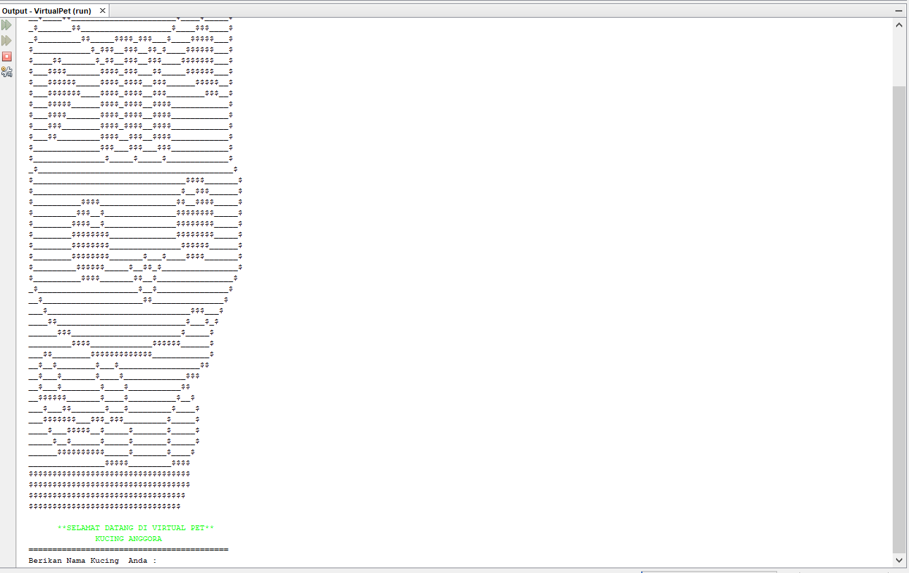

Gambar 5.1 Ketika Program Virtual Pet di Running

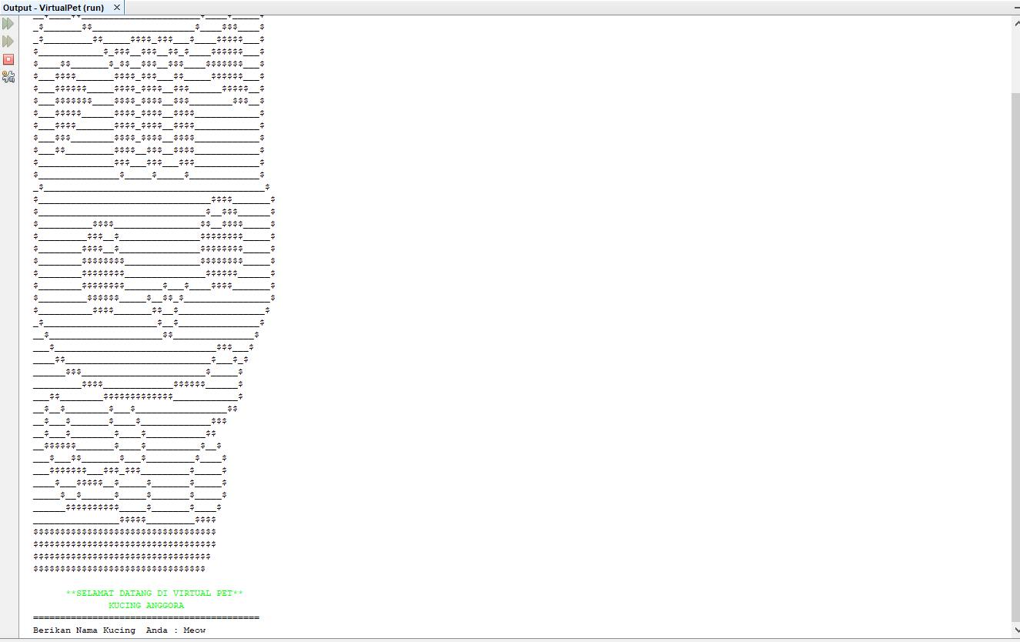

Gambar 5.2 Ketika User Menginputkan nama kucing

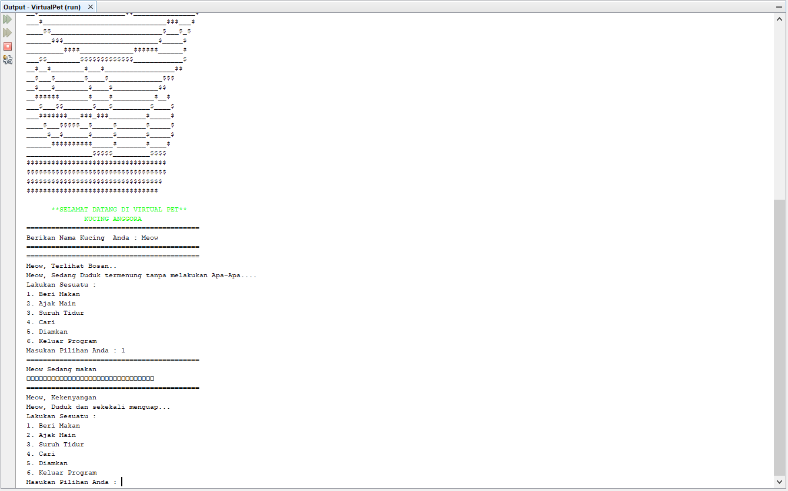

Gambar 5.3 Ketika user menginputkan 1 (Beri Makan)

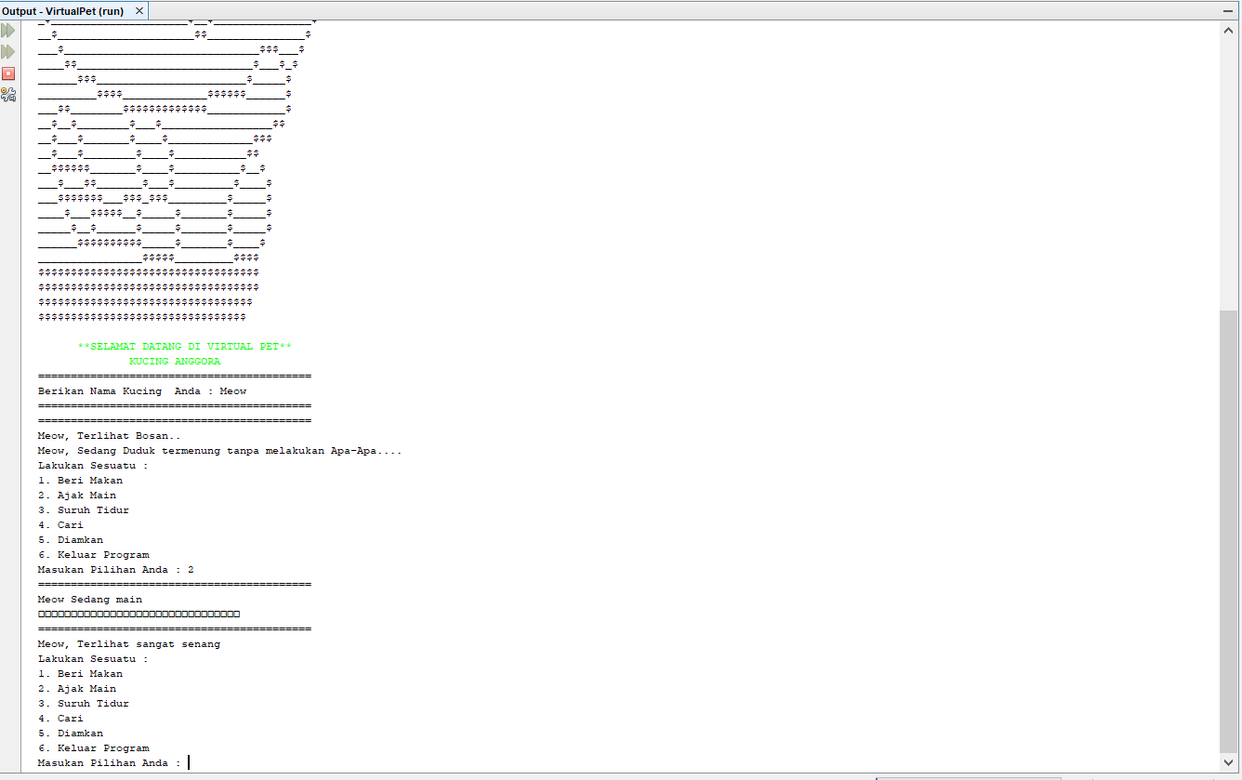

Gambar 5.4 Ketika user menginputkan 2 (Ajak Main)

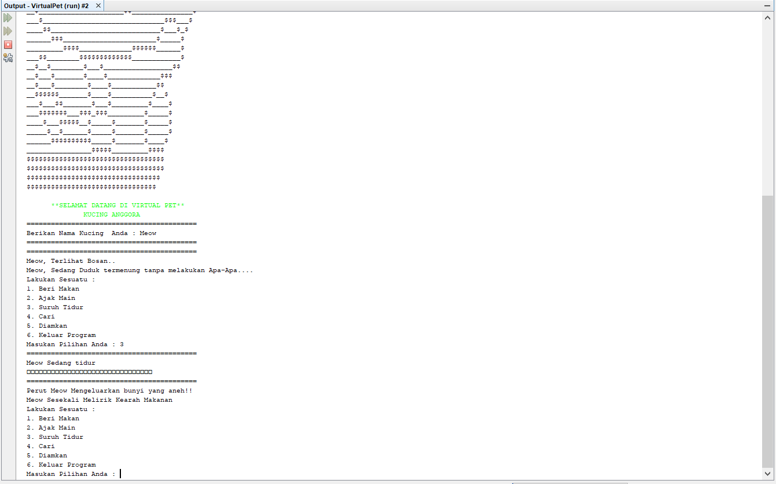

Gambar 5.5 Ketika user menginputkan 3 (Suruh Tidur)

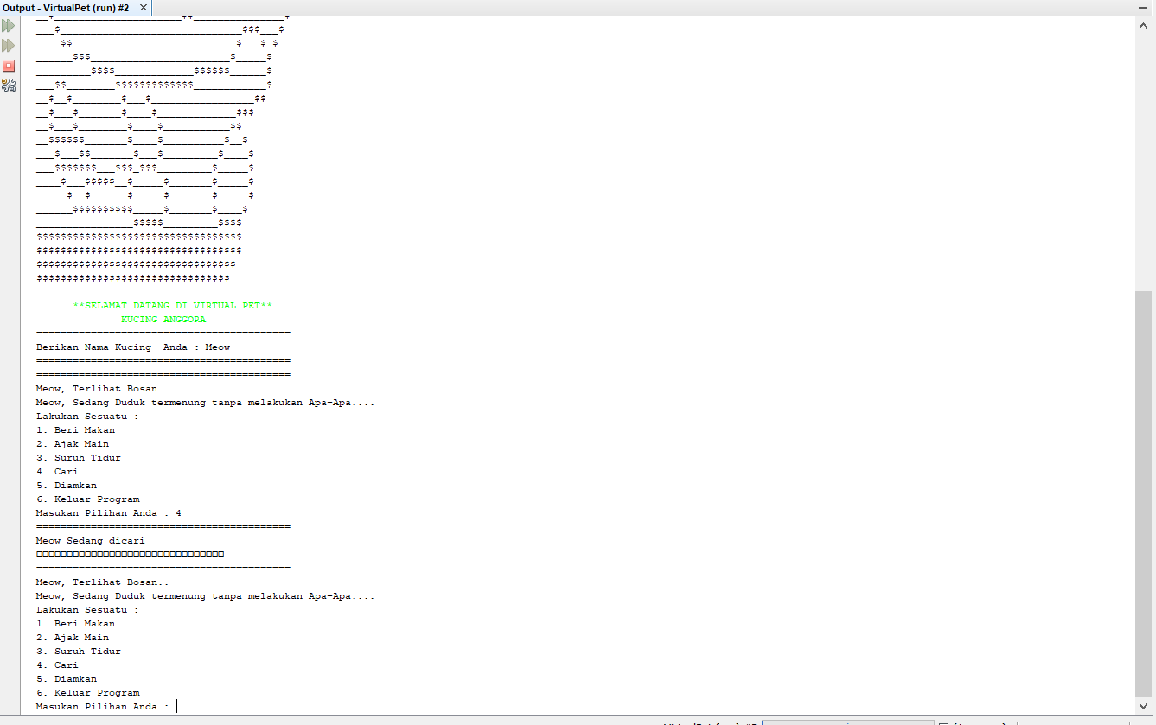

Gambar 5.6 Ketika user menginputkan 4 (Cari)

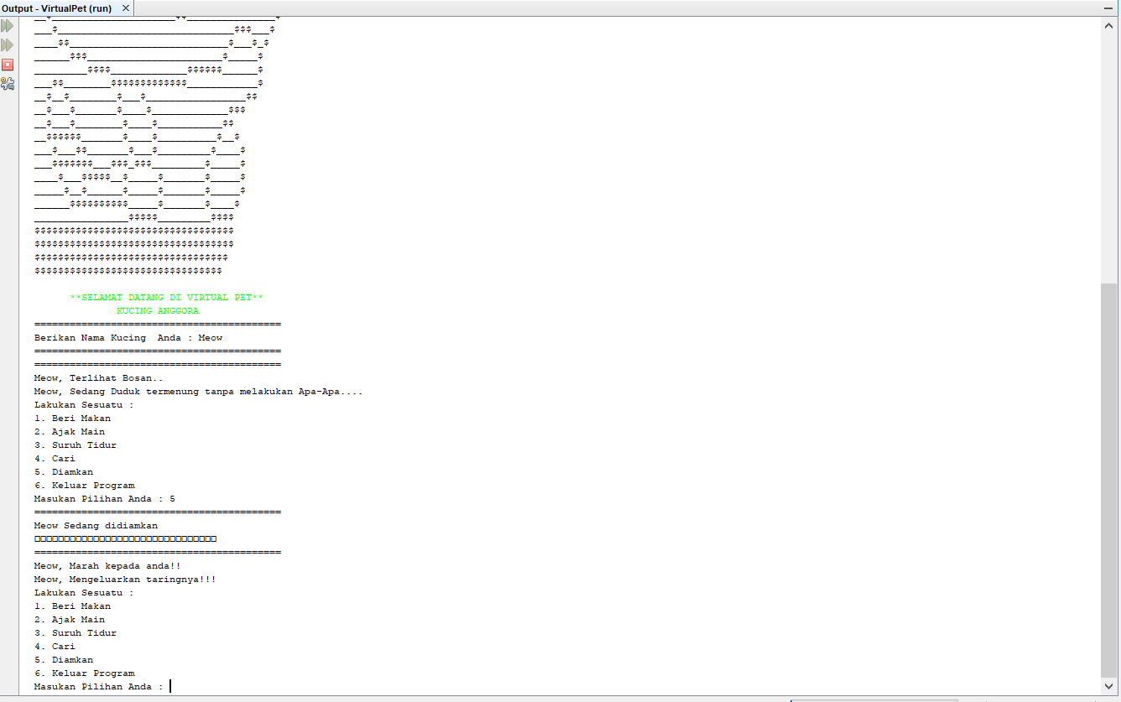

Gambar 5.7 Ketika user menginputkan 5 (Diamkan)

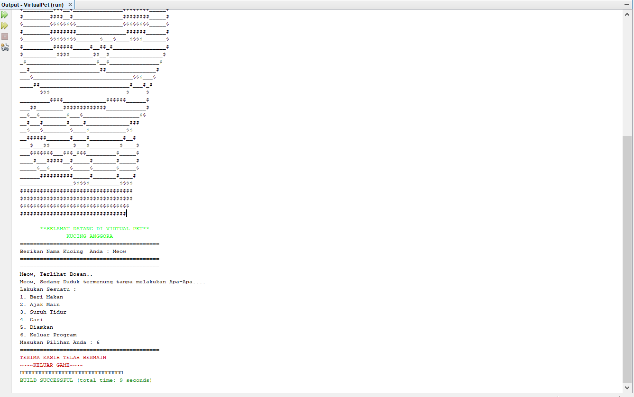

Gambar 5.8 Ketika user menginputkan 6 (Keluar Program)